Big Data Analysis Project Code Report
Online Shopping
PythoNinjas

By:
Clément Fabien - 12230194
Guillaume Jolivalt - 12230078
Pierre Bénot - 12230200
Elmurodjon Abdullajonov - 12200319
The dataset we chose to use is named “Online Sales in USA” and was found on kaggle.com. There are 36 columns such as order_id, order date, item_id and price. The dataset has around 280,000 lines, and here is a little part of it:
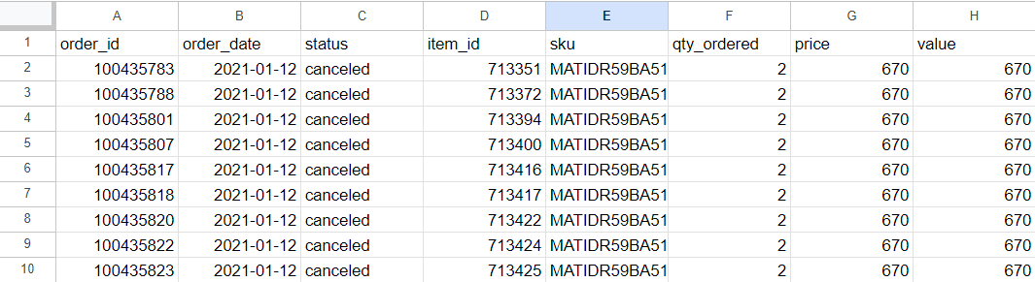
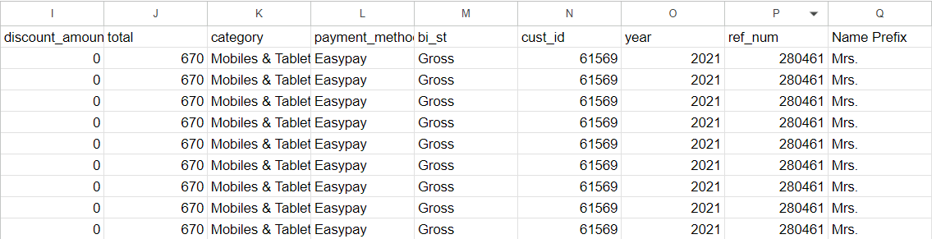
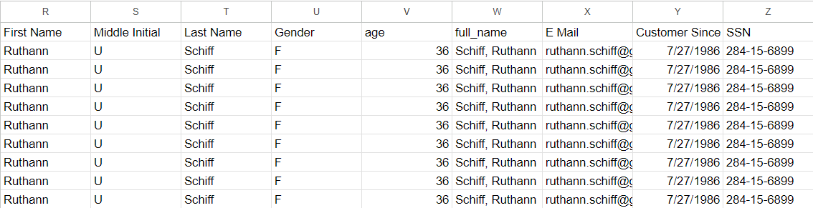
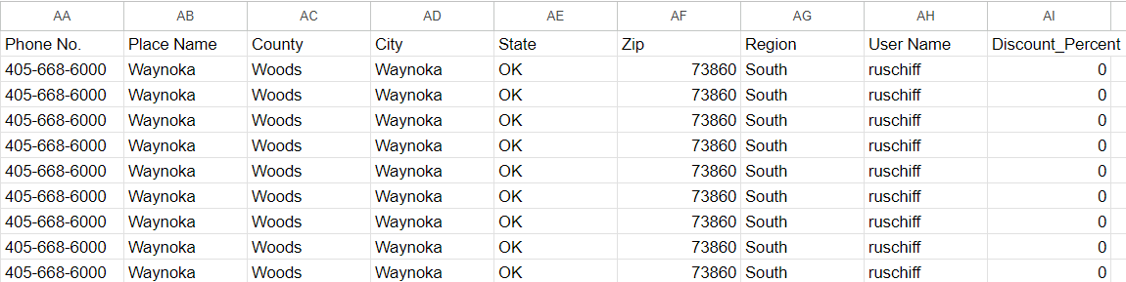
We firstly tried to make some graphs with Microsoft Excel to see what types of data could be relevant. The only problem was that we couldn’t import all the lines of the dataset in the Excel files because the dataset was too big so we were forced to use only a sample of it, resulting in a result a little less accurate. Here are some examples:
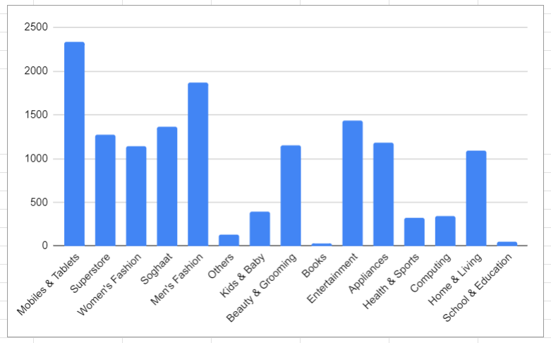
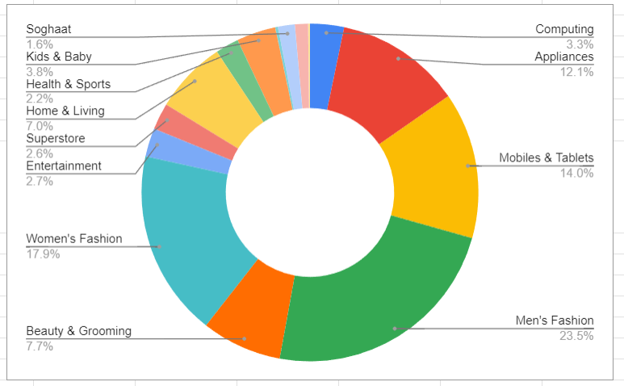
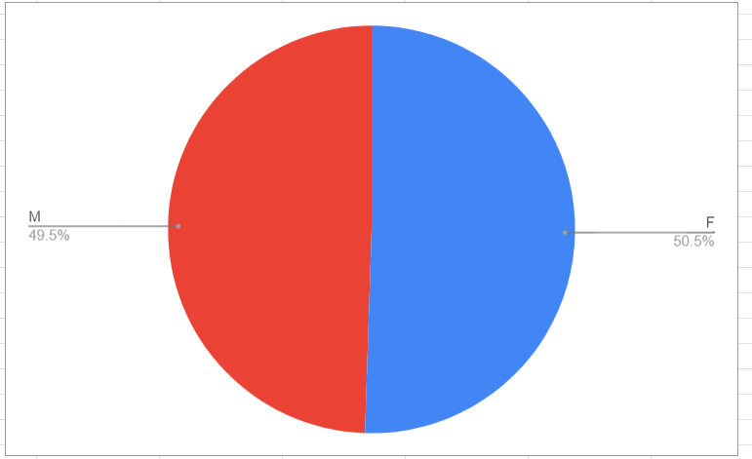
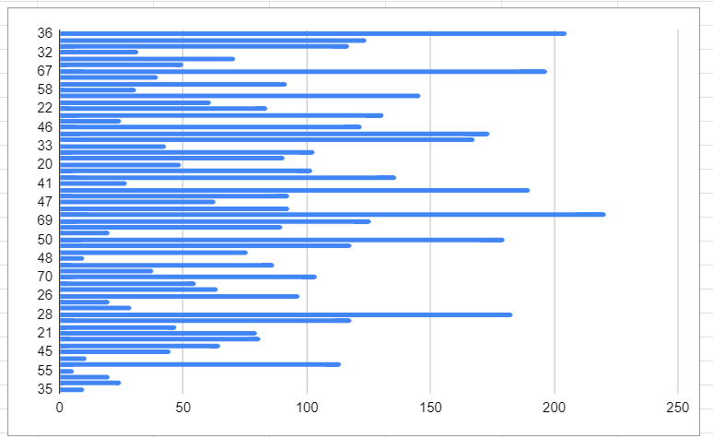
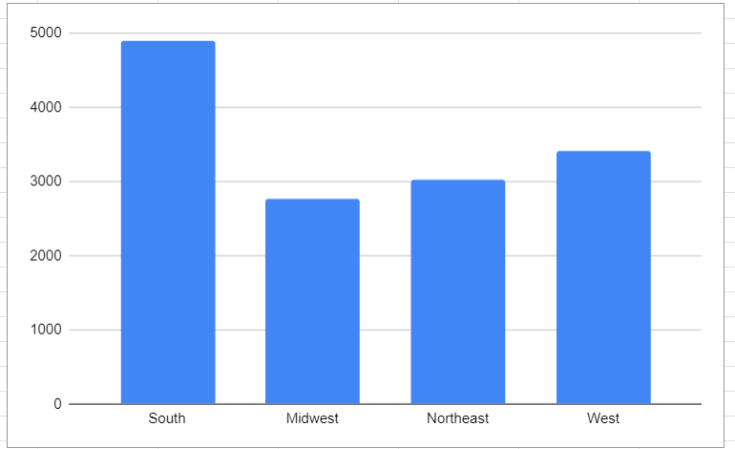
So we have decided to do some python code on Google Collab with the libraries Matplotlib and Panda. Before doing this we asked some questions to ChatGPT to help us find some ideas and we sometimes asked it for help to make our python code.
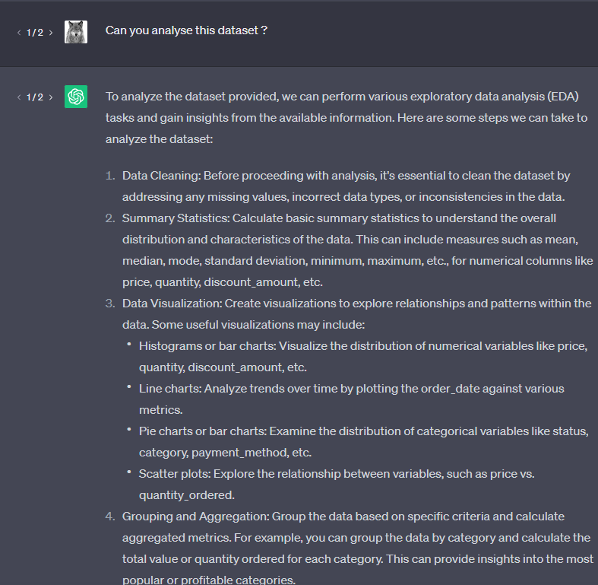
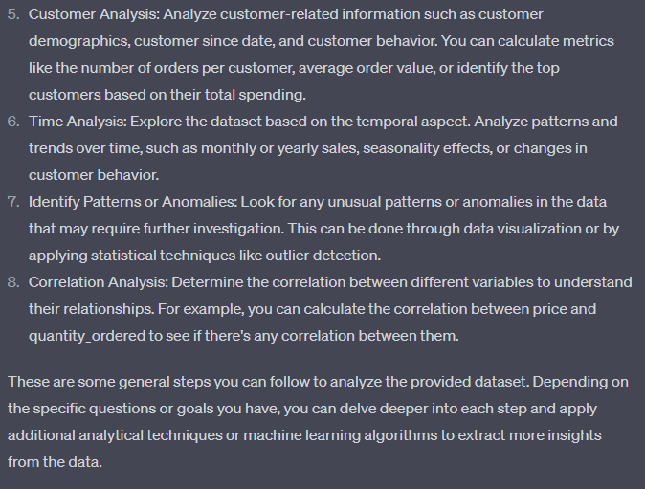
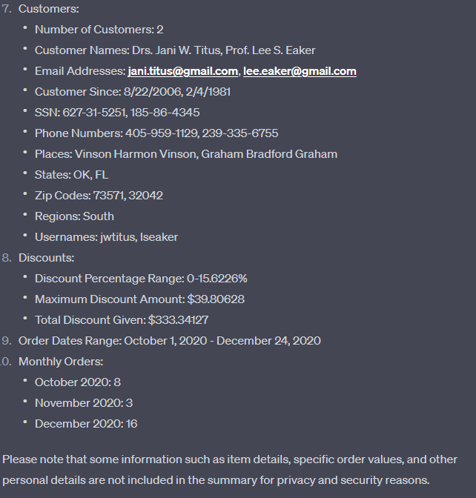
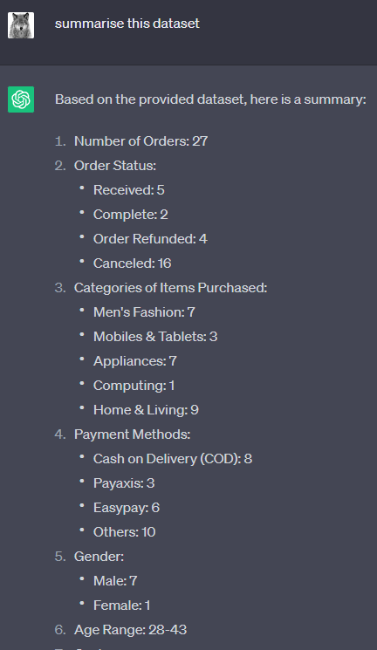

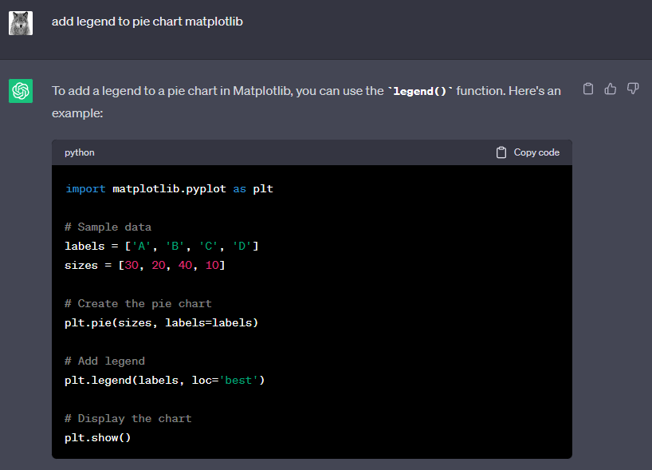
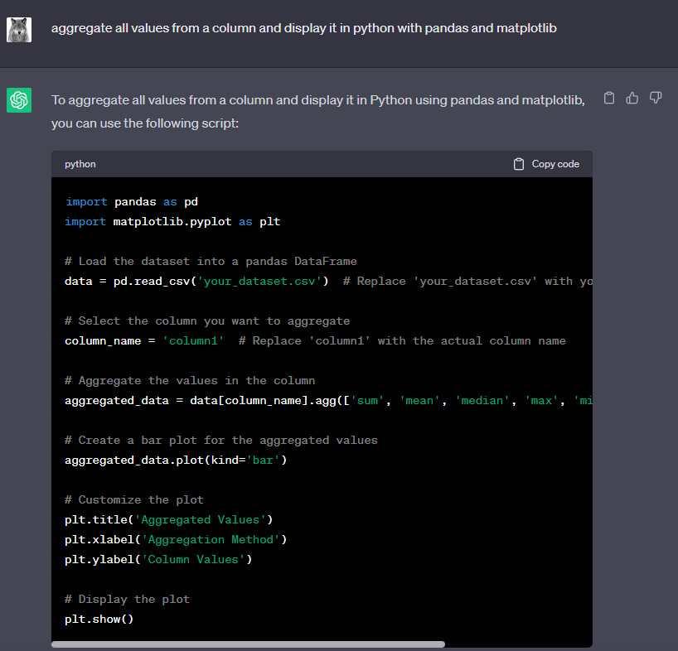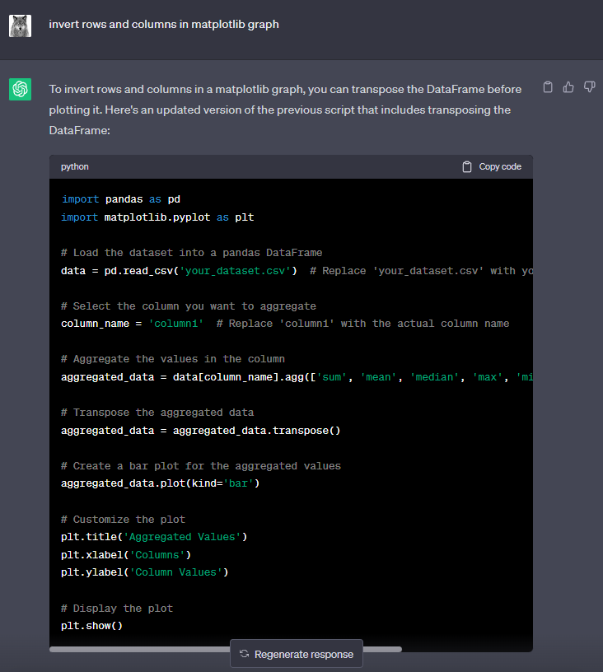

After doing this we started coding with python. Here is the import of all the libraries:
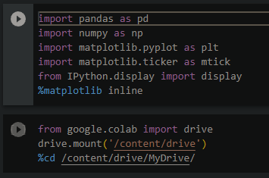
Here is the import of the dataset:
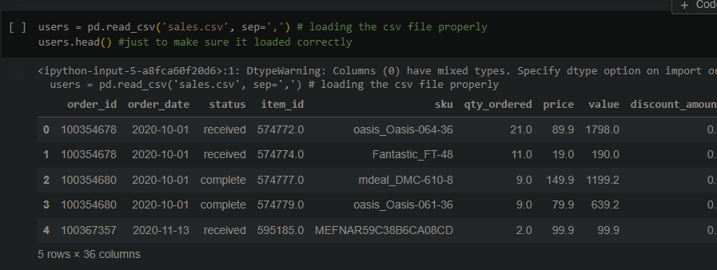
After importing the dataset, we had to know in what age groups the dataset was based on. For that, we first had to remove the duplicates of the table. Those were assigned to the variable called noDup. To remove the duplicates, we based ourselves on the “User Name” column of the dataset since each user name is unique.
​​noDup["age"].value_counts().sort_index(): In the "age" column of the noDup DataFrame, this line counts the number of times each distinct age appears. The sort_index() method arranges the values by their position in the index (in this case, the age values) in ascending order after the value_counts() method produces a Series containing the counts. This line, plot(kind="line"), creates a line plot based on the Collection generated in the previous step. In the form of a line chart, it shows the number of people by age.
We have given a plot title with plt.title, plt.ylabel is given to the y axis of the illustration as well as plt.xlabel to the x axis. At last we have called plt.show() to show the visualization of the data. Here is the line chart:
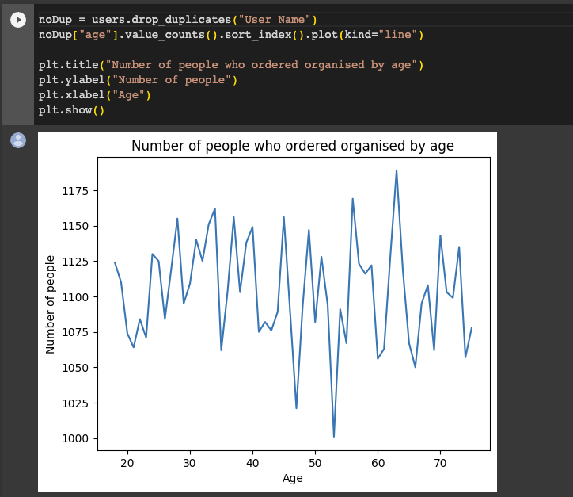
Next we wanted to know if a majority of a certain gender was present in the dataset.
The line: noDup["Gender"].value_counts().sort_index(), calculates the number of times each distinct gender appears in the "Gender" column of the noDup DataFrame. We don’t want duplicates here again as they could falsify the data. The sort_index() method arranges the data points (in this case, the gender values) by their index (which is returned by the value_counts() method) in chronological order. plot(kind = ‘bar’) creates a bar plot. Vertical bars are used to represent the number of clients for each gender.

As it has been done above, plt.title(“Number of customers by genders”) is set to be the title of the visualization. plt.ylabel and plt.xlabel are also given for the x and y axis and at last the data is visualized with plt.show().
Here is the graph:
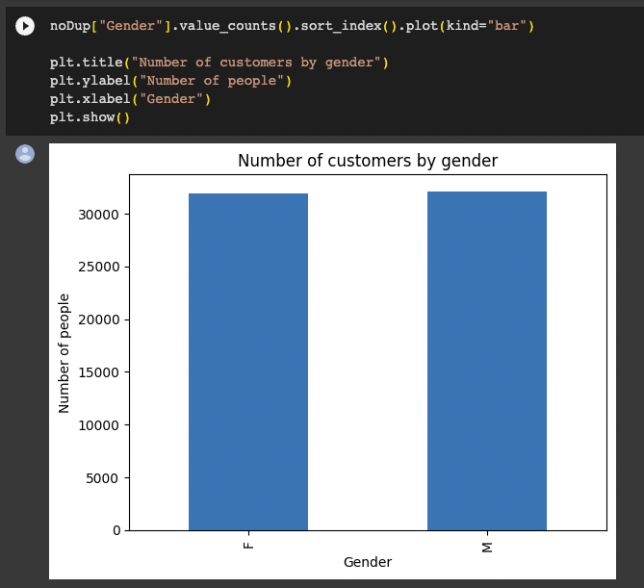
We then needed to look for each category and which one was the most used. To do so, we have analyzed the “category” column of the dataset.
In this chunk of code, we have given a list of labels called ‘labels’ and then, from the users data frame we have accessed the ‘category’ section of data. As usual, value_counts() generates a Series containing the counts, and sort_index() ascendingly forms the values according to their index (in this example, the categories).
plt.pie(categories), creates a pie chart to illustrate the portions based on the values in categories. We then created a legend for a better reading of the chart with those lines: title="Categories", loc="upper left", bbox_to_anchor=(1.04, 1), plt.legend(labels). By connecting each category name (from the labels list) with its appropriate square in the pie chart, we can provide a legend to the plot. The legend's placement is controlled by the bbox_to_anchor and location variables, while the title variable determines its title. With plt.title, the title of the pie chart has given and illustrated through plt.show()
Here is the final result:
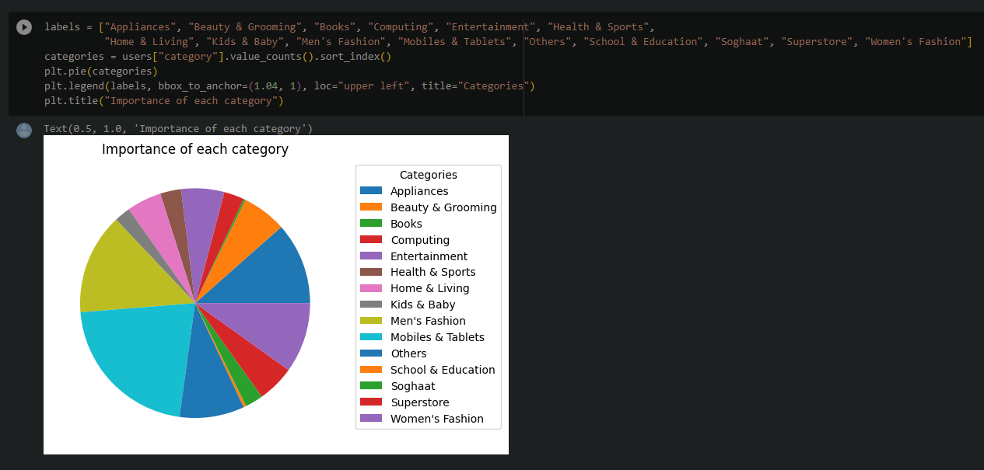
Next we wanted to know from what region in America each customer came from. We need, yet again, the noDup variable which doesn’t have the duplicates.
The code starts with, regions = noDup["Region"].value_counts().sort_index(): Within the "Region" field of the noDup DataFrame, we count the number of times each distinct region appears. Again, value_counts() produces a Series containing the counts, and sort_index() ascendingly sorts the values according to their index (in this example, the regions). Then we have a list of labels, in which the regions have been mentioned. With a list of labels, we have generated a pie chart with: plt.pie(regions). plt.legend(labels, bbox_to_anchor=(1.04, 1), loc="upper left", title="Region". With the addition of this legend we can link each region name (found in the labels list) to the relevant area of the pie chart. The legend's positioning is controlled by the bbox_to_anchor and loc variables, while the title parameter determines its title.plt.title has been mentioned to demonstrate the title of the graph and illustrated with plt.show().
Here is the Pie Chart:
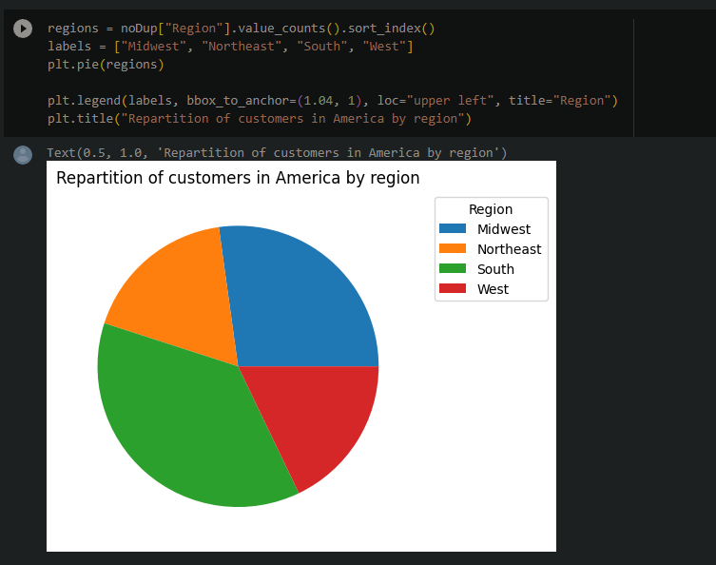

Finally we needed to see in which month the most used category had been bought. To do so we took every month we had from the dataset and we looked how many times the category appeared in each month.
We have taken a list of months and category labels to present the chart. Months start in October 2020 until September 2021. We then initialized an empty map called d with d = {}. With for i in range(12), use the loop that iterates in the range of 12, in our case, 12 months. Users['month']==Months[i] & Users['category']=="Mobiles & Tablets"]))) = d[Months[i]] This line counts the instances in which the "category" field is "Mobiles & Tablets" and the "month" field in the users a data frame matches the current month (Months[i]). It creates a pair of keys and values in the dictionary d that ties the count to the appropriate month.
list(d.keys()) = courses The keys (months) from the dictionary d are created in a list titled courses by the following line.
list(d.values()) = values This line generates the values (count of Mobiles & Tablets bought) from the dictionary d into a list named outcomes.
fig = plt.figure(figsize = (10, 5)): This line generates a fresh diagram item for the plot with the given size.
plt.bar(courses, values, color='blue', width=0.5) This line creates a bar plot with the data list as the y-axis (which correspond to the count of Mobile & Tablet purchases) and the courses list as the x-axis (which correspond to the months). These bars are 0.5 wide and have a blue tone.
margin equals 0.2/plt.gcf().get_size_inches()[0]: This line determines the subplot adjustment margin size.
Applying the obtained margin value, a line of plt.gcf().subplots_adjust(left=margin, right=1.-margin) changes the subplots' left and right margins.
The heading of the plot has been set to "Amount of Mobiles & Tablets Purchased During the Year" using the command plt.title("Amount of Mobiles & Tablets Purchased During the Year").
And here is the final graph we will be using: